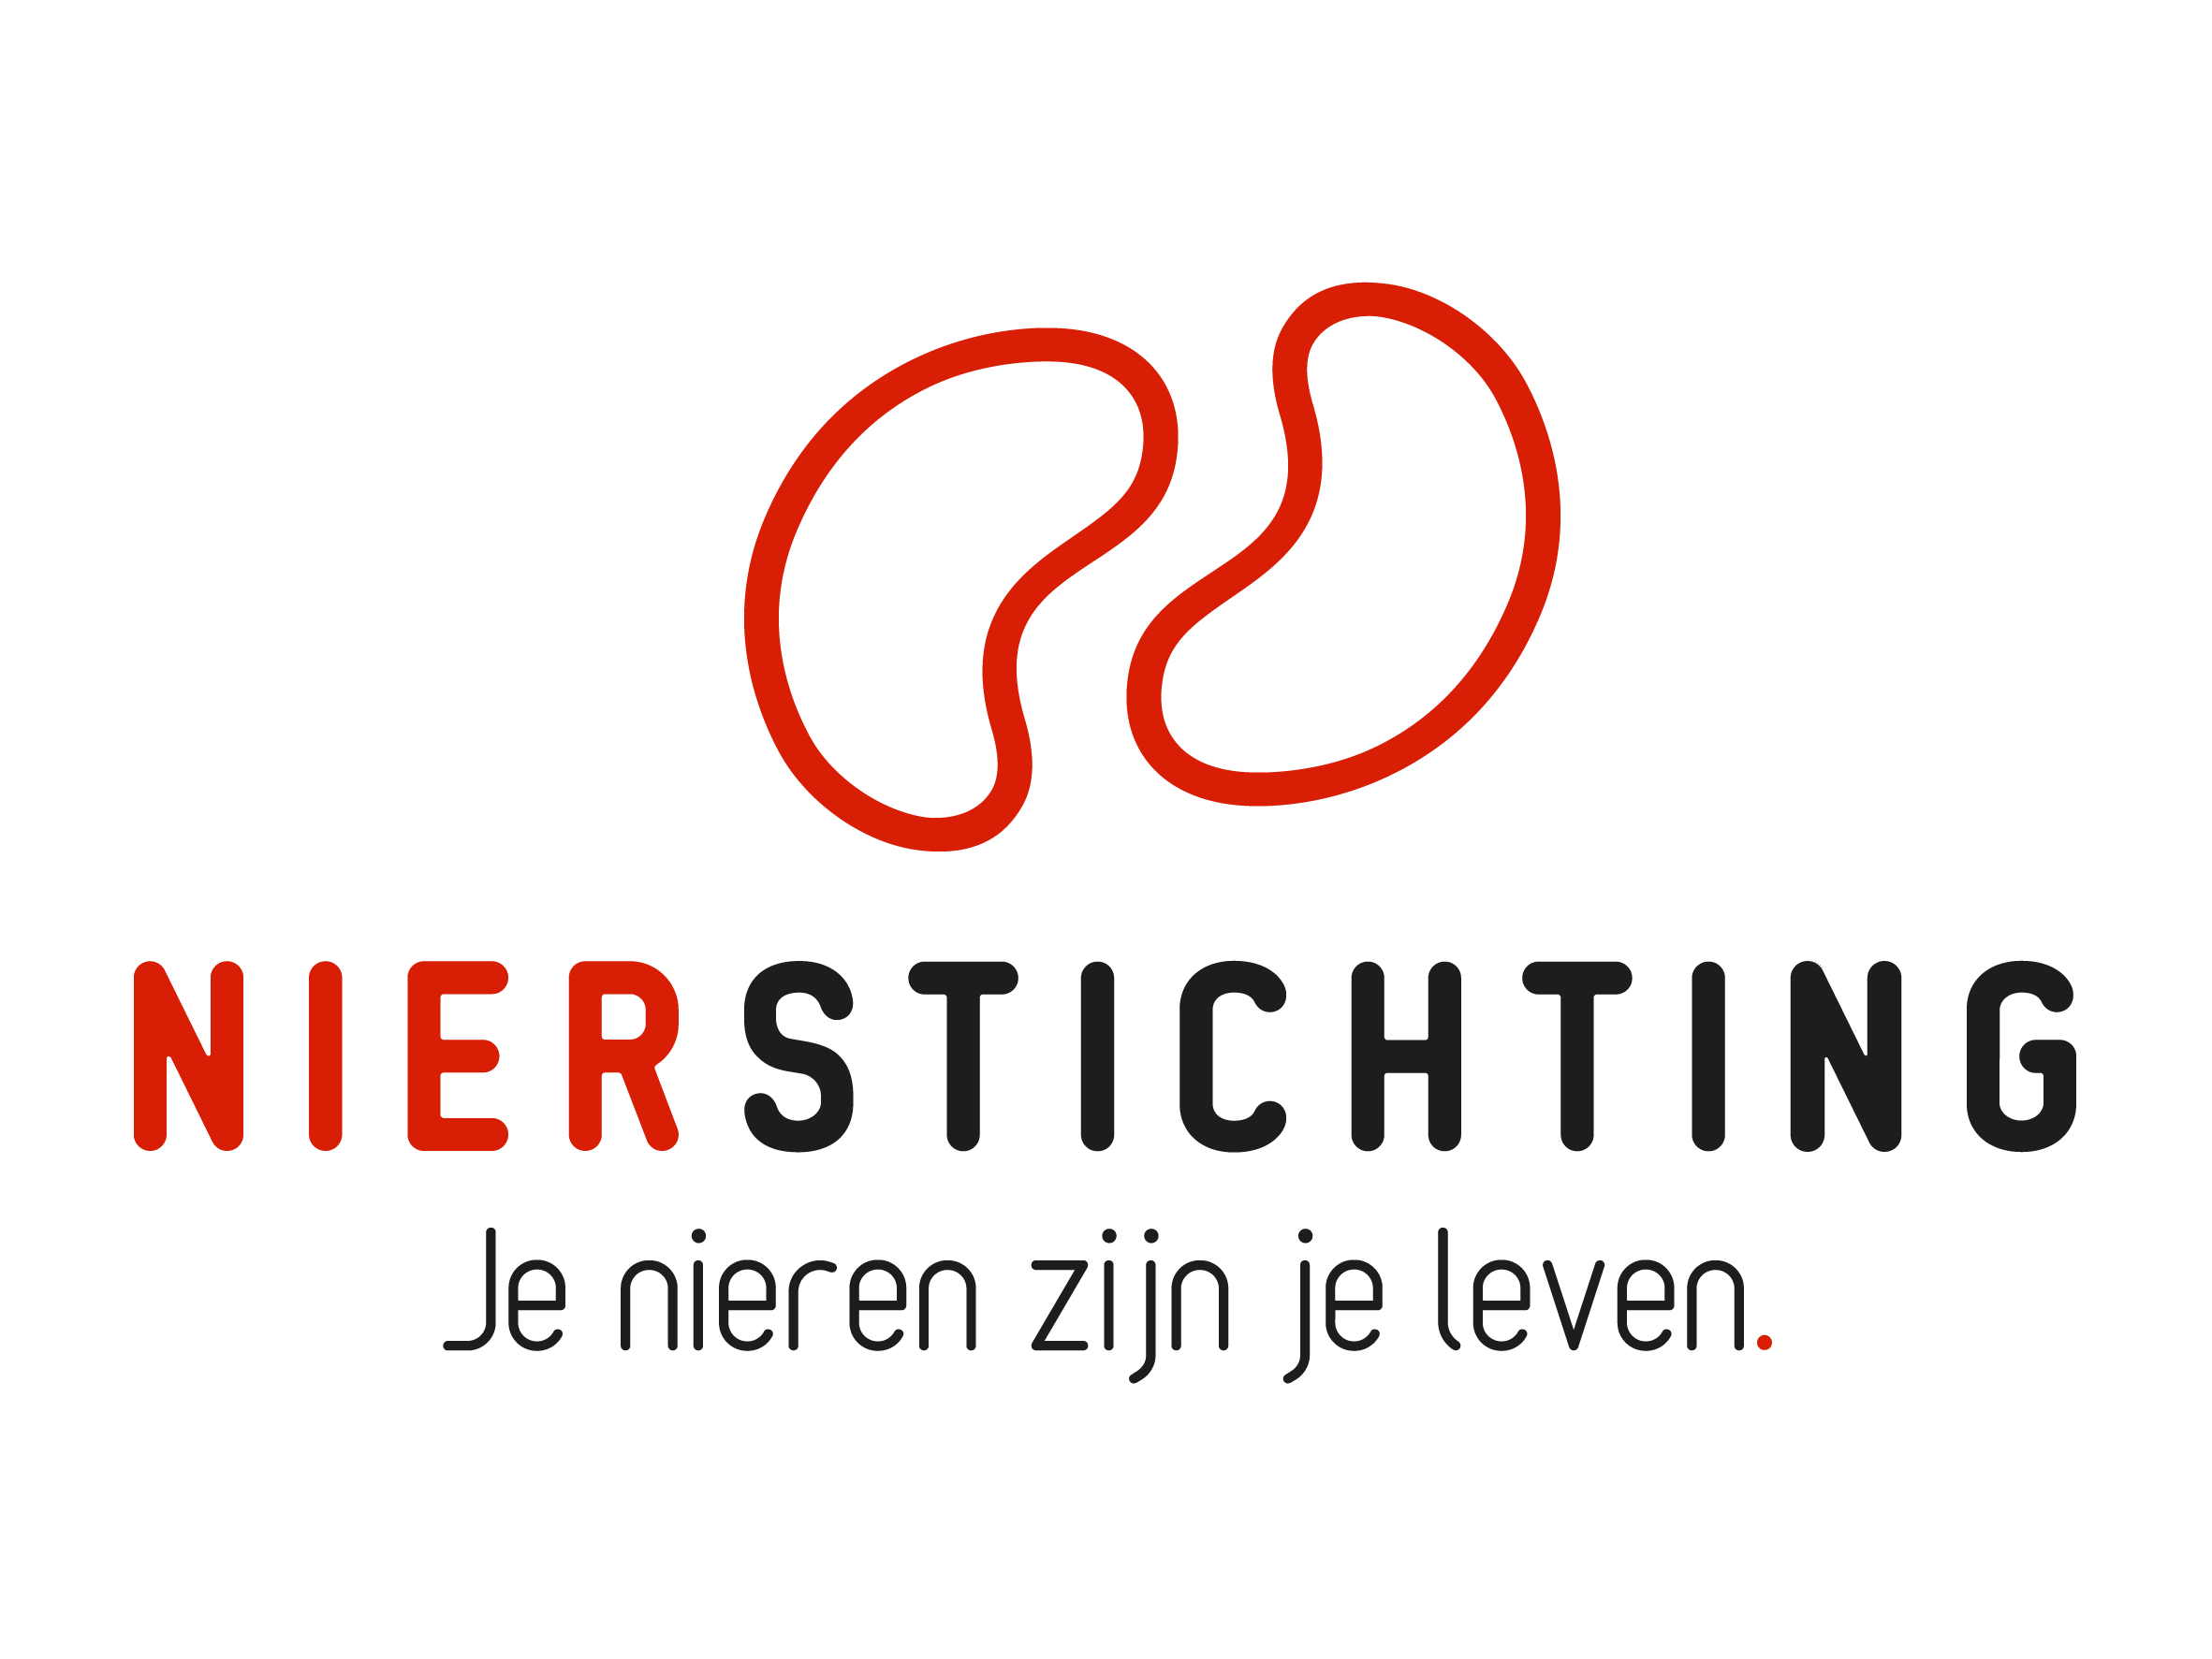
Dutch Kidney Foundation
Final Report form
Student Researcher Grant
25 February 2025

The Dutch Kidney Foundation (DKF) General Grant Requirements (Subsidievoorwaarden Nierstichting Nederland) apply to all awarded DKF subsidies as well as all proposals for DKF subsidies. Applicability of general and other conditions of the applicant, the applicant's institute and of third parties is explicitly excluded.

Nierstichting / Dutch Kidney Foundation
+31 (0)35 697 8015
research@nierstichting.nl

Instructions for completing and submitting this form
- Maximum word counts specified are fixed limits that must not be exceeded. Please fill in the number of words used where asked.
- Forms should be filled in using Arial 10 pt.
- Instructions and/or sections in the form must not be deleted (even if the section is not applicable).
- Please convert the completed final report form, including electronic signatures, in a searchable pdf-file. The maximum file size is 5 MB.
- Add the formal final report of the institute, abstracts and publications as PDF files. Please note that PDFs should be uploaded separately from this report in MIDAS. Merge multiple PDFs into one file.

I. Items 1 to 8: To be filled in by the Student researcher

1. Project
Project code
Project title
Start date
End date
Duration in months
DKF budget

2. Student Researcher
Name
Institute
Department

3. Project Leader Abroad (if applicable)
Name
Institute
Department

4. Summary of the Student Researcher Project (original and changes, max. 500 words)
Number of words used:
If applicable, add changes in bold script. Provide a short motivation for changes.

5. Project Results (max. 1000 words)
Number of words used:
Give a short description of the results. Order the results along the given objectives and aims.

6. Discussion (max. 500 words)
Number of words used:
If you have submitted an additional report or a publication together with the present report, you may refer here to the specific section where this information can be found.

7. Conclusions and recommendations, e.g. for further research (max. 500 words)
If you have submitted an additional report or a publication with the present report, you may refer here to the specific section where this information can be found.
Number of words used:

8. Student research project and future career (max. 500 words)
What did you learn during this project? Has the project contributed to pursuing your ambitions? Or has it influenced your prior ambitions? How? What are your current ambitions, do you intend to stay involved in the renal field? If yes, how? Doing research and/or other activities? Is there anything else that you would like to share with us? For any additional comments or updates on your career, please contact us at research@nierstichting.nl.
Number of words used:

II. To be filled in by the Project Leader/Supervisor in the Netherlands

IIa. Project Leader in the Netherlands
Name
Institute
Department

IIb . Overall Assessment Score
Rate using an ‘X’.
How do you assess the scientific quality of the research performed by the student researcher and its documentation in this Final Report?

Poor | Fair | Average | Good | Excellent
1. ☐ | 2. ☐ | 3. ☐ | 4. ☐ | 5. ☐

III. Signatures
 | Name and position | Signature | Date
Project leader/supervisor (NL)

Student researcher / Student or PhD Fellow

